# **NAS-GEM-80 FDC CARD**

**Instruction Manual & Functional Description**



**Contents**

**NAS-GEM-80 FDC CARD** 1

1 Introduction 3

2 Components 4

3 Construction 6

3.1 Before you start construction 6

3.2 Order of construction 6

4 Functionality 7

4.1 Links 7

4.2 SW1 – Base Port Select 7

4.3 LKB2 – Configuration Switch 8

4.4 Ports 8

4.4.1 For port 0xE4 8

4.4.2 For port 0xE5 9

5 Configuration 10

5.1 Without A Scope 10

5.2 With A Scope 10

6 Notes on Components 11

6.1 LKB2 Configuration Switch 11

6.2 SW1 Decode Header 11

6.3 C4 11

6.4 IC’s U15, U20, U21 11

6.5 1793 FDC Controller 11

7 Errata 16

8 Reference Images 17

# Introduction

This card has been designed to be a form, fit and function replacement for the Nascom Floppy Disk Controller, which is proving to be a very difficult item to source for the Nascom / Gemini retro community.

The card has been tested against original Teac FD-50E/F drives without observed issues under NAS-DOS 1.4

Further testing with CP/M and PolyDos is planned

***Note:*** The card is designed to handle 5.25-inch drives. Support for 8-inch drives has been removed (***Did anyone ever use this?***)

# Components

|  |  |  |
| --- | --- | --- |
| **Reference** | **Quantity** | **Value** |
|  |  |  |
| **Capacitors** |  |  |
|  |  |  |
| C1 (Tantalum) | 1 | 1uF |
| C2 | 1 | 33pF |
| C3 | 1 | 150pF |
| C4 (Polyester Film) | 1 | 4n7 |
| C5 | 1 | 1nF |
| C6 (Tantalum) | 1 | 100uF |
| C7 (Tantalum) | 1 | 22uF |
| C8, C9, C101 - C106 (Tantalum) | 8 | 10uF |
| DC1 - DC24 – Decoupling caps | 25 | 10nF |
|  |  |  |
| **Resistors** | **Quantity** | **Value** |
|  |  |  |
| R1 | 1 | 100K |
| R2 | 1 | 5K6 |
| R3 | 1 | 4K7 |
| R4 | 1 | 10K |
| R5 | 1 | 22K |
| R6 | 1 | 1M |
| R7 | 1 | 1M |
| R8 | 1 | 15K |
| R9 | 1 | 1K |
| R10 | 1 | 4K7 |
| R11 | 1 | 150 |
| R12 | 1 | 150 |
| R13 | 1 | 150 |
| R14 | 1 | 150 |
| R15 | 1 | 150 |
| R16 | 1 | 10K |
| R17 | 1 | 10K |
| R18 | 1 | 10K |
| R19 | 1 | 10K |
| R20 | 1 | 10K |
| R21 | 1 | 10k |
| R22 | 1 | 10K |
| R23 | 1 | 10K |
| R24 | 1 | 10K |
| R25 | 1 | 10K |
| R26 | 1 | 4K7 |
| R27 | 1 | 4K7 |
| R28 | 1 | 220K |
| R29 | 1 | 150K |
| R30 | 1 | 1K0 |
| R31 | 1 | 470 |
|  |  |  |
| **IC’s** | **Quantity** | **Value** |
|  |  |  |
| U1 – DIP 20 | 1 | 74LS245 |
| U2 – DIP 16 | 1 | 74LS138 |
| U3 – DIP 14 | 1 | 74LS10 |
| U4 – DIP 14 | 1 | 74LS04 |
| U5 – DIP 16 | 1 | 74LS365 |
| U6 – DIP 16 | 1 | 74LS163 |
| U7 – DIP 16 | 1 | 74LS257 |
| U8 – DIP 16 | 1 | 74LS257 |
| U9 – DIP 14 | 1 | 74LS32 |
| U10 – DIP 14 | 1 | 74LS32 |
| U11 – DIP 14 | 1 | 74LS02 |
| U12 – DIP 16 | 1 | 74LS195 |
| U13 – DIP 20 | 1 | 74LS273 |
| U14 – DIP 40 | 1 | WD1793 |
| U15 – DIP 14 (Static sensitive) | 1 | 4013B |
| U16 – DIP 14 | 1 | 7407 |
| U17 – DIP 14 | 1 | 74LS04 |
| U18 – DIP 16 | 1 | 74LS123 |
| U19 – DIP 14 | 1 | 7438 |
| U20 – DIP 16 (Static sensitive) | 1 | 4046B |
| U21 – DIP 14 (Static sensitive) | 1 | 4016 |
| U22 – DIP 14 | 1 | 74LS14 |
| U23 – DIP 14 | 1 | 7406 |
| U24 – DIP 16 | 1 | 74LS123 |
|  |  |  |
| **Other Items** | **Quantity** | **Value** |
|  |  |  |
| D1 – LED | 1 | LED 3mm |
| LK1, LK3, LK4 (optional) | 3 | Switch SPST Slide, 6.7x4.1mm, W7.62mm, P2.54mm |
| LK2 | 1 | Switch DPDT, 3 pins, P2.54mm |
| RV1 | 1 | 50K, Cermet type potentiometer |
| SW1 | 1 | Switch or header, x8, W7.62mm_Socket |
| LKB2 | 1 | Switch SW_DIP_x10, W7.62mm_Socket |
| PL1 | 1 | Connector, Header 2x17, P2.54mm |

# Construction

## Before you start construction

Inspect the PCB for any visible signs of damage

Plug the board into an 80-BUS and power it up.

* Verify no latent shorts exist
* Verify correct voltages on power rails

Select your components:

* Turned pin sockets are recommended due to robustness and reliability
* Tantalum capacitors can be temperamental. Make sure they are inserted with the correct polarity, are of good quality and are overrated voltage wise.

U15, U20 & U21 are static sensitive. Handling precautions need to be observed.

## Order of construction

The recommended order of construction is:

* Resistors
* Sockets
* Decoupling capacitors
* Tantalum capacitors
* Switches
* LED
* Wire header
* Insert IC’s

# Functionality

## Links

The board contains 4 links, which can be implemented as switches or hard wired with links depending on the user’s preference.

|  |  |
| --- | --- |
| **Link (Default)** | **Usage** |
| LK1 Open | Ready |
| LK2 A -> C | Side Select. Set A -> C for 1793 Side Select |
| LK3 Open | Spare – Port x4 Bit 5 |
| LK4 Open | Spate – Port x4 Bit 7 |

## SW1 – Base Port Select

This allows the board to be mapped to ports 0x20, 0x40, 0x60, 0x80, 0xA0, 0xC0, 0xE0. The default is 0xE0. User options are to either hard wire a link, use a link block or use an 8-way DIL switch.

|  |  |
| --- | --- |
| **Connect Pins** | **Port Base Address** |
| 1 to 16 | N/A |
| 2 to 15 | 0x20 |
| 3 to 14 | 0x40 |
| 4 to 13 | 0x60 |
| 5 to 12 | 0x80 |
| 6 to 11 | 0xA0 |
| 7 to 10 | 0xC0 |
| 8 to 9 (Default) | 0xE0 |

## LKB2 – Configuration Switch

This is implemented as a 10-way DIL switch. The switch settings are as follows:

|  |  |  |  |
| --- | --- | --- | --- |
| **Switch** | **Usage** | **2MHz Default** | **4MHz Default** |
| 1 | Set write pre-compensation | Off | Off |
| 2 | Only one of SW1, SW2 or SW3 should be selected | Off | On |
| 3 | … | Off | Off |
| 4 | Clock divide by 2 (For 2MHz systems) | On | Off |
| 5 | Clock divide by 4 (For 4MHz systems) | Off | On |
| 6 | Clock divide by 4 (For 2MHz systems), VCO=500KHz | On | Off |
| 7 | Clock divide by 8 (For 4MHz systems), VCO=500KHz | Off | On |
| 8 | Select single /. double density | On | On |
| 9 | Disable / enable track 43 pre-compensation | On | On |
| 0 | Disable write pre-compensation | On | Off |

## Ports

The board uses six ports, selected from the base port (Default 0xE0). These are:

|  |  |  |
| --- | --- | --- |
| **Port** | **Read** | **Write** |
| 0xE0 | 1793 Status register | 1793 Command register |
| 0xE1 | 1793 Track register | 1793 Track register |
| 0xE2 | 1793 Sector register | 1793 Sector Register |
| 0xE3 | 1793 Data register | 1793 Data register |
| 0xE4 | Drive selection | Drive select control |
| 0xE5 | INTRQ / DRQ status | N/A |

### For port 0xE4

|  |  |  |
| --- | --- | --- |
| **Bit** | **Read** | **Write** |
| 0 | Drive select 0 | Drive select 0 |
| 1 | Drive select 1 | Drive select 1 |
| 2 | Drive select 2 | Drive select 2 |
| 3 | Drive select 3 | Drive select 3 |
| 4 | Side select | Side select (When LK2 A->C) |
| 5 | LK3 | Motor 0=off, 1=on |
| 6 | Density (0=low, 1 = high) | Density (0=low, 1 = high) |
| 7 | LK4 | N/A |

### For port 0xE5

|  |  |  |
| --- | --- | --- |
| **Bit** | **Read** | **Write** |
| 0 | 1793 INTRQ | N/A |
| 1 | 0=Ready, 1=Not Ready | N/A |
| 2 | N/A | N/A |
| 3 | N/A | N/A |
| 4 | N/A | N/A |
| 5 | N/A | N/A |
| 6 | N/A | N/A |
| 7 | 1793 DRQ | N/A |

# Configuration

Once the board has been built and configured via links options and switches, the VCO center frequency needs to be set. This can be done in two ways:

## Without A Scope

The following steps are required to perform the configuration:

1. Ensure the board is disconnected from any drives (Disconnect PL1)
2. Turn the potentiometer at VR1 anti-clockwise until the LED illuminates
3. Turn the potentiometer at VR1 a quarter turn clockwise

## With A Scope

The following steps are required to perform the configuration:

1. Ensure the board is disconnected from any drives (Disconnect PL1)
2. Observe the signal at U20 Pin 3
3. Turn the potentiometer until a 500KHz square wave is observed

# Notes on Components

All the components used have been selected at time of design to be readily available via eBay and other sources.

## LKB2 Configuration Switch

It is recommended to fit a 20-pin socket and use a 10-way DIL switch

## SW1 Decode Header

The socket at SW1 is recommended to be of the turned pin variety so as to allow easier insertion of the header. The default header is a 16-way DIL header.

An alternative is to use Single-In-Line (SIL) Turned Pin Socket 0.1 Inch Pitch strips which are readily available instead of a header. These are then snipped down to the desired length before being inserted into the socket and the desired wire links being made.

An 8-way DIL switch may also be used if one is available.

## C4

This capacitor is of the film type in the original design. I have used an ***Axial Polypropylene Film Capacitor*** here without issue. Other types (e.g. ceramic) may work but that configuration is untested.

## IC’s U15, U20, U21

These parts are static sensitive. Handling precautions need to be observed.

## 1793 FDC Controller

A 1797 controller, in theory, may be substituted, but that configuration is untested. To use the 1797 Side-Select feature, set LK3 to B -> C

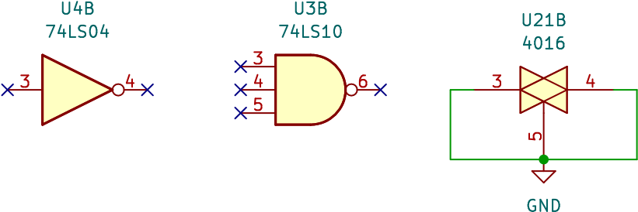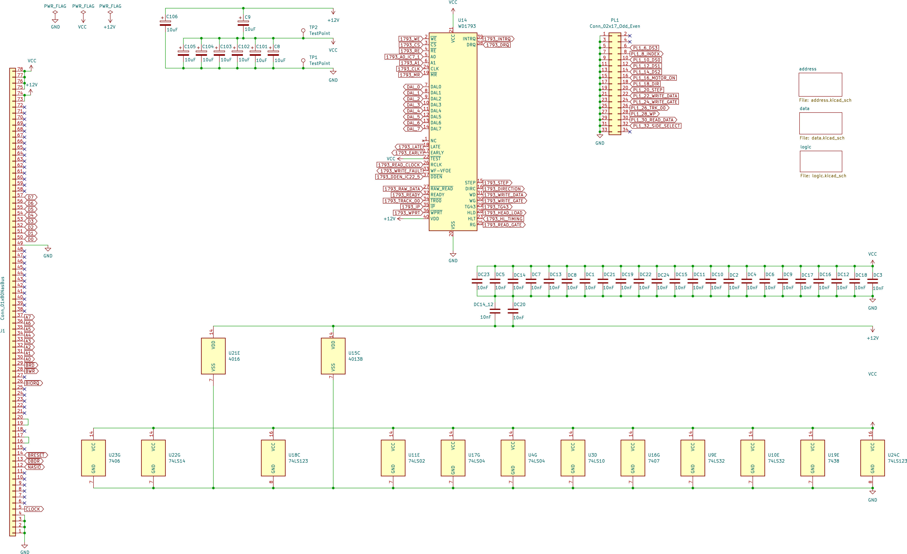

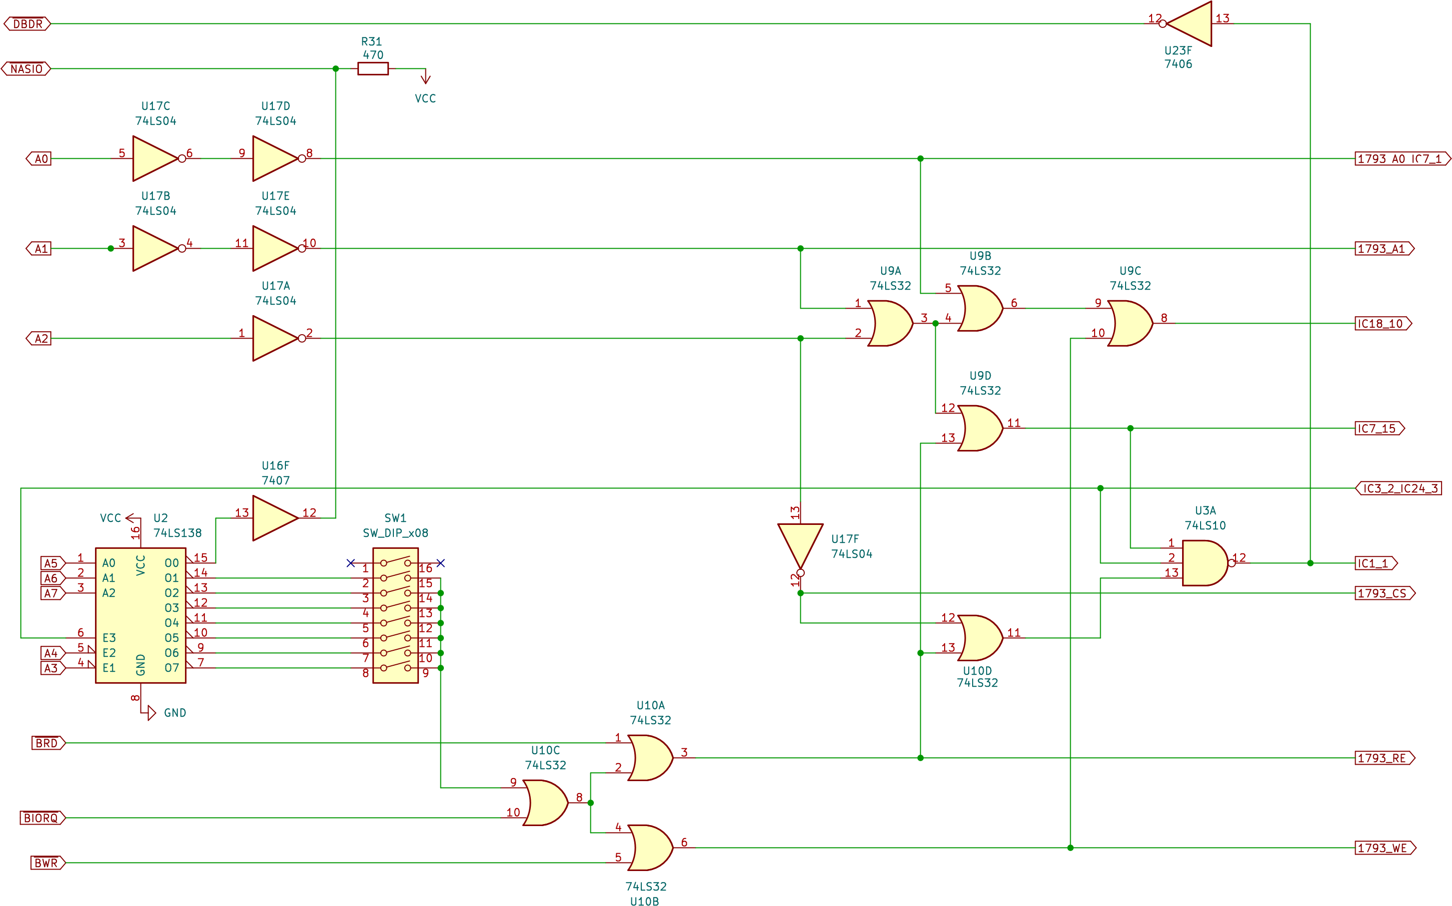

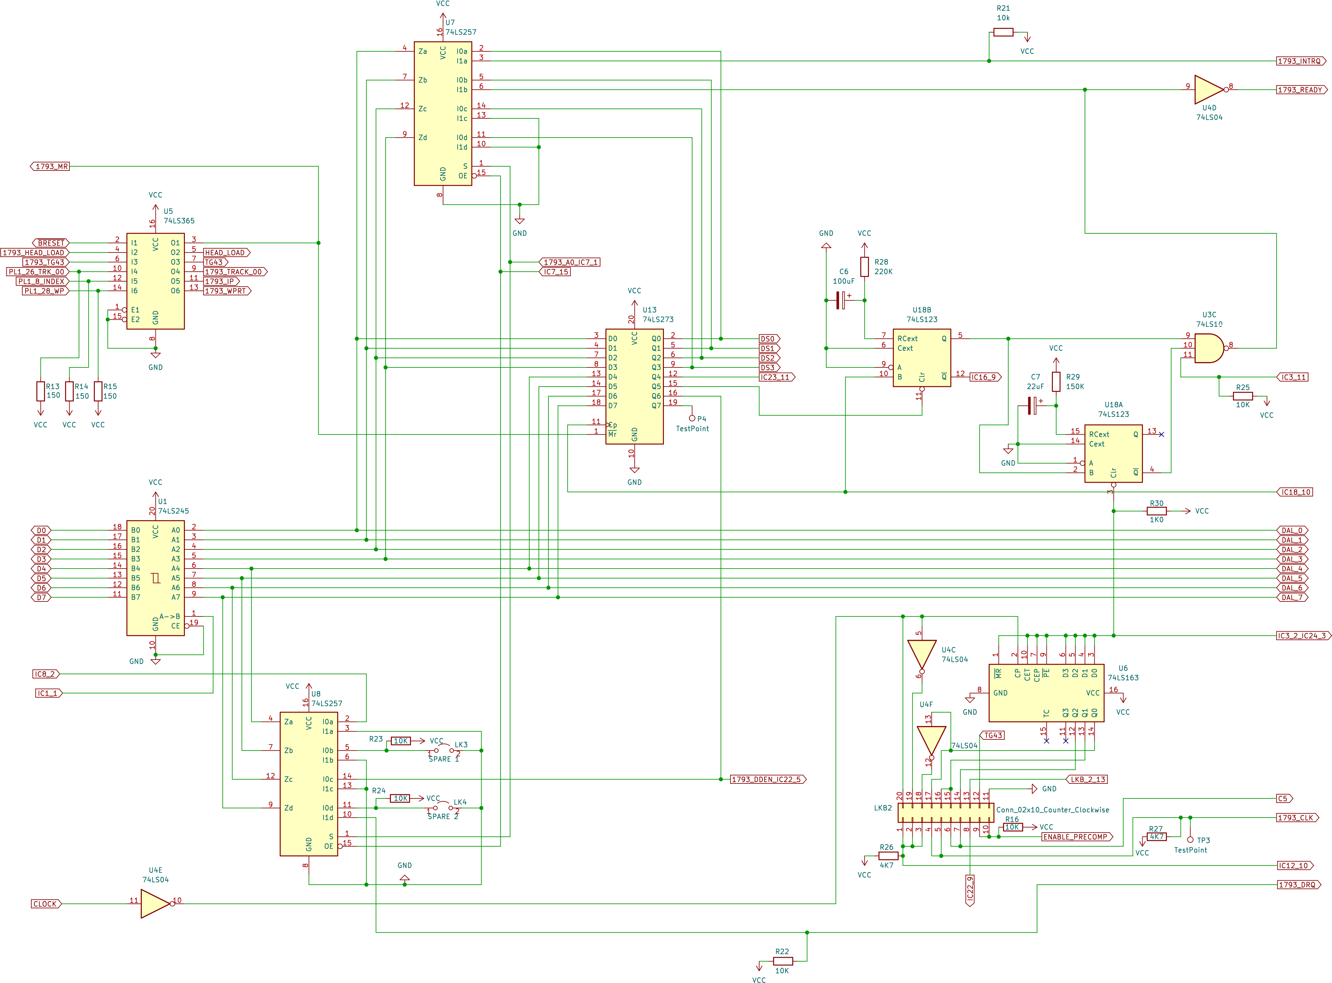

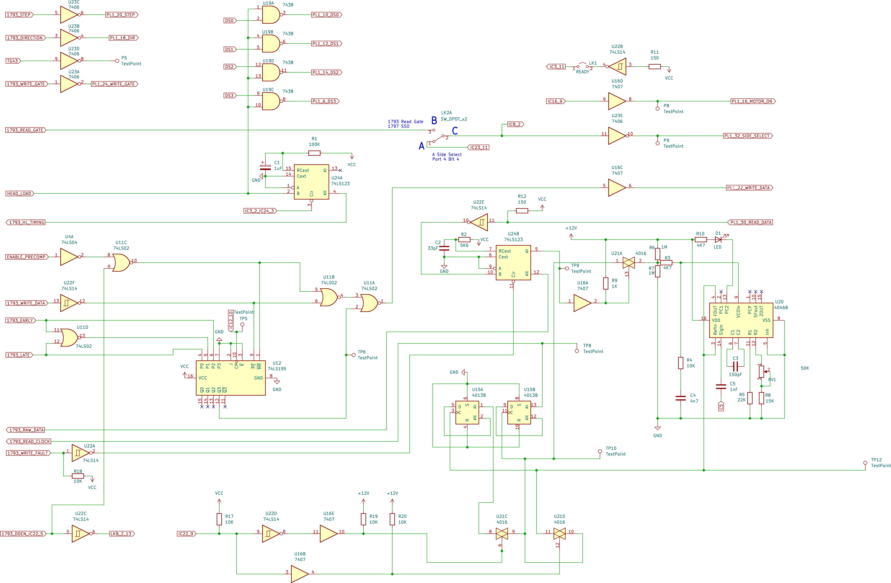

# Errata

Initial release boards (1.2.0) have an incorrect ground line for C1.

The capacitor at location C1 should be:

1. Mounted on the back of the board
2. The positive leg should go through the existing positive through plated hole for the component
3. The negative leg should go to pin 14 of U24

This modification fixes an issue with the unstable operation of the Head Load monostable

# Reference Images

<Insert photo’s here>